**EYE OPPORTUNITY GROUP**

**26 CASTLETON WAY, EYE, SUFFOLK IP23 7BH**

**Tel: 01379 870975**

**email:** [**eyeopportunitygroup@btconnect.com**](mailto:eyeopportunitygroup@btconnect.com)

**Registered Charity Number 287907**

**SAFEGUARDING PROCEDURES BRIEFING**

September 2023

**Reporting of safeguarding concerns to EOG’s Safeguarding Officers**

All actual/suspected abuse must be reported in confidence to the Safeguarding Officer, below. Concerns must be reported where possible on the **same day** the concern arises or as soon as possible and must be followed up **in writing within 24 hours**. If the concern is urgent and a child is at significant risk of harm do not allow a delay in your reporting if you cannot contact the Safeguarding Officer.

Safeguarding Officers:

Safeguarding Officer: **Sanchia Brandreth**

Safeguarding Deputy: **Laura Stretch**

Safeguarding Officer on the Trustee Board: **Laura Chapman**

The four types of abuse outlined in *Working together to safeguard children, 2015:*

* Physical abuse
* Emotional abuse
* Sexual abuse
* Neglect

**Contact Customer First 0808 800 4005 or police on 999 if an emergency**

**Referrals forms**

Referral to children’s social care services should be made using the [Multi-Agency Referral Form](https://earlyhelpportal.suffolk.gov.uk/web/portal/pages/marf" \l "h1).

All professionals making telephone referrals to Suffolk’s children’s social services (including via Customer First) MUST confirm this in writing **within 24 hours**. If you are worried about the ***immediate*** safety of a child/young person and cannot contact a Safeguarding Officer call the police on 999. You can also contact the LSCP.

Your report must be accurate and where possible use the child’s exact words if they disclosed the information to you, not your own.

The report must be signed and dated, including the year. Ensure the form is submitted safely following the directions on the online form and ensure a copy is saved and sent to EOG’s Safeguarding Officer in the same manner marked “Confidential SG”.

**Suffolk Safeguarding Partnership’s Threshold of Need**

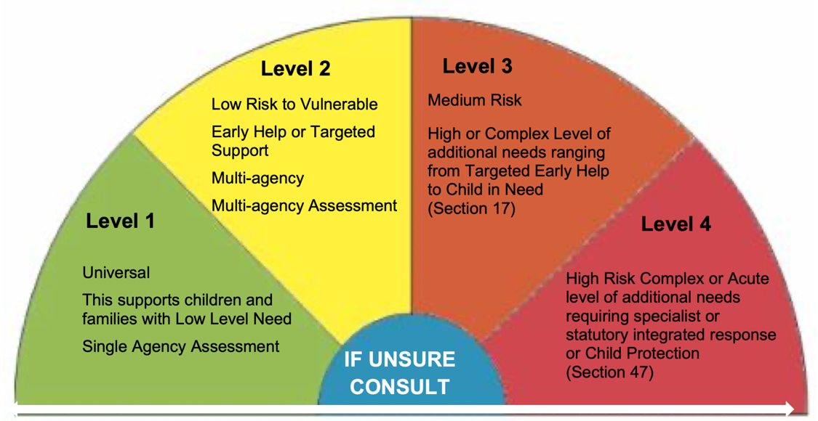

The LSCP’s [Threshold Matrix](https://static1.squarespace.com/static/62ea37b2f412d231ae2c2f35/t/6397478b9bec9118ce5a039d/1670858635778/Suffolk-Threshold-Matrix-2022.pdf) gives an indication of the type of support families may require at each level and is summarised in the image above. Please refer to the full matrix for further information.

**Understanding Thresholds**

Level 1 - Universal - All children and young people accessing mainstream services with low-level need can be met through a single agency assessment.

Level 2 - Low Risk to Vulnerable - Early Help or Targeted Support - Children with emerging needs or low level CCE (child criminal exploitation) / CE (child exploitation) concerns can be met with the support of a multi-agency assessment or for CCE a Diversion Referral to the Suffolk Youth Justice Service.

Level 3 - Medium Risk - Children with multiple or complex needs including medium risk of CCE/CE have to be met by targeted services or by a multi-agency CAF assessment, or for CCE a Diversion Referral to Suffolk Youth Justice Service or by a Child In Need social work assessment.

Level 4 - High Risk - Children and young people who present with complex needs/risk. Including high level CCE/CE concerns/risk. They will require specialist services and multi-agency statutory response.

**Flowchart for referral for actual or suspected abuse**

**Concerns**

**Suspicion/allegation of abuse by: child disclosure, observation,**

**report by another person, anonymous communication**

**RECORD Sign and Date**

**↓**

**Consult**

**If appropriate, speak with the Safeguarding Officer. All can speak informally with Multi-Agency Safeguarding Hub to discuss whether a referral is necessary**

**IMPORTANT: Any consultation should not delay a referral**

**RECORD Sign and Date**

**↓**

**Action**

**DO NOT INVESTIGATE**

**Refer to Suffolk Safeguarding Partnership and/or Police. You or the Safeguarding Officer should make the referral. Parents and carers should be advised that you are doing this unless this might put the child at risk or cause any delay in referring**

**RECORD Sign and Date**

**↓**

**Confirm**

**DO NOT INVESTIGATE**

**Verbal referrals must be followed by a written referral within 24 hours**

**RECORD Sign and Date**

**↓**

**Commitment**

**You may be required to provide other information, as required**

**RECORD Sign and Date**

**Reporting procedure for allegations against staff/volunteers/trustees**

If the allegation is against an EOG member of staff the allegation must be reported immediately, at least **within one working day**, to the EOG’s Safeguarding Officer. If the allegation is against the Safeguarding Officer then the allegation must be reported to EOG’s Safeguarding Officer on the Trustee Board. The Safeguarding Officer/or Officer on the Trustee Board must then report the allegation to the Local Area Designated Officer (LADO) on the same day.

**LADO central telephone number: 0300 123 2044**

**Email: LADO@suffolk.gov.uk**